Affiliated to Pokhara University
POKHARA ENGINEERING COLLEGE

Phirke, Pokhara-8

A
Project Proposal on
E-SPEAK

Submitted by :
Ashbin Rajbomsi(21075356)
Dhiren Sen Thakuri(21075361)
Santosh Baniya(21075380)

Supervisor :
Assist. Prof. Er. Ramesh Baral

Submitted to :
Research Management Cell
Pokhara Engineering College
2025
Table of Contents
Chapter 1 Introduction 1
1.1 Background 1
1.2 Statement of Problem 1
1.3 Objectives 1
1.4 Scope of project 2
1.5 Limitations 2
Chapter 2 Literature Review 3
2.1. Early Civic Tech Platforms 3
2.2. The Rise of AI and NLP in Civic Applications 3
2.3. Location-Based and Context-Aware Civic Reporting 3
2.4. Feedback Mechanisms and Transparency 4
2.5. AI Retraining and Continuous Improvement 4
2.6. Challenges and Considerations 4
2.7. Summary 4
Chapter 3 Methodology 5
Chapter 4 Project Schedule 8
Chapter 5 Expected Outcomes 9
References: - 10

Chapter 1 Introduction

Background
In Nepal, civic complaints (like damaged roads, poor sanitation, or broken streetlights) are often reported through informal channels like social media or verbal complaints, leading to inefficiencies in how local governments respond. Our system solves this by offering a smart, location-based platform where citizens can report problems, nearby users can support them, and authorities are alerted when enough people engage making local governance faster, transparent, and more community driven.

1.2 Statement of Problem
These problem statements clearly outline the key issues in the system:
- Citizens have no structured way to report and track local civic issues.
- Authorities receive delayed, duplicate, or low-priority complaints.
- There's no smart system to escalate issues based on public urgency or engagement.

1.3 Objectives
Our project aims to achieve key objectives that includes:
- Develop a web-based platform for structured, location-based civic issue reporting with AI-powered classification, sentiment analysis, and duplicate detection.
- Promote active community engagement through upvoting, commenting, polls, and smart notifications to ensure transparency and participation.
- Enable efficient government response through automated alerts, real-time dashboards, and data-driven insights, supporting better resource allocation and inclusive governance across urban and rural areas.

1.4 Scope of project
This project develops a web-based platform for structured, location-based civic issue reporting with AI-powered classification, sentiment analysis, and duplicate detection. It includes community engagement features such as up-voting, commenting, and smart notifications to enhance citizen participation and transparency. The system enables automated alerts to authorities based on priority and public feedback, supporting efficient government response and inclusive governance.

Limitations
The project does come with some limitations.
- The platform may have limited functionality in low-bandwidth or unstable network areas.
- AI may misclassify issues with unclear or incomplete data, especially for local languages.
- It depends on active participation from both users and government officials.

Chapter 2 Literature Review

AI-Driven Civic Issue Reporting and Engagement Platforms
The rise of Civic Technology (Civic Tech) has transformed citizen-government interactions. Platforms now allow users to report issues (e.g., broken infrastructure, sanitation) and receive updates from authorities. Recently, the integration of Artificial Intelligence (AI) and Natural Language Processing (NLP) has enabled automated classification, urgency detection, and feedback loops (Linders, 2012).

2.1. Early Civic Tech Platforms
Early platforms like FixMyStreet and SeeClickFix offered basic issue submission and location tagging but required manual sorting of complaints, slowing response times (King & Brown, 2007). Crowd-sourced tools like CitySourced and Ushahidi showcased the potential of civic participation but lacked automated issue handling (Meier, 2015).

2.2. The Rise of AI and NLP in Civic Applications
AI and NLP now allow platforms to automate key processes: classifying issues, detecting urgency through sentiment analysis, and flagging priority cases (Shin & Hwang, 2020; Dey et al., 2021). However, AI models can be biased or inaccurate if not properly trained (Liu et al., 2019), requiring ongoing updates and validation.

2.3. Location-Based and Context-Aware Civic Reporting
Modern systems integrate GPS and GIS, generating heatmaps of reported issues and enabling location-based alerts (Batty et al., 2012). However, privacy must be protected when using location data (Perng & Kitchin, 2018).

2.4. Feedback Mechanisms and Transparency
Effective platforms provide status updates to users, boosting trust and engagement (Nam & Pardo, 2011). Features like user ratings and the ability to reopen issues help ensure accountability (Linders & Wilson, 2014).

2.5. AI Retraining and Continuous Improvement
AI models must be regularly retrained to stay effective as new issues arise, and user behavior evolves (Mehrabi et al., 2021). Admin tools for retraining classifiers help maintain system relevance.

2.6. Challenges and Considerations
- Misclassification can reduce user trust.
- Bias and fairness must be monitored (Mehrabi et al., 2021).
- Privacy concerns arise from handling location and sentiment data (Zhou et al., 2020).

2.7. Summary
AI and NLP can significantly improve civic issue platforms by automating classification, prioritization, and feedback. For E-Speak, combining modular AI engines, transparent communication, and location-aware engagement can enhance responsiveness and citizen participation while challenges of fairness, privacy, and AI accuracy must be carefully addressed.

Chapter 3 Methodology
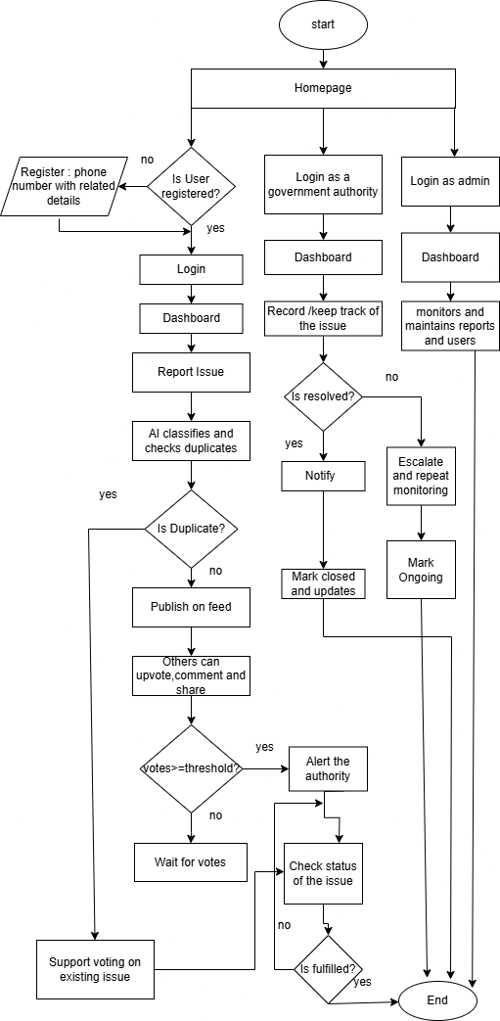
Flowchart:

Tools used:
Figure: Flowchart of E-speak
For the dynamic front-end, strong back-end, flexible data handling, AI and NLP we will use the following tools to develop our system and the tools are given below:
1. Programming Languages:
- JavaScript/JSX - Frontend development
- Python- Backend development
- SQL - Database queries
2. Frontend Technologies
- React - UI framework for building user interfaces
- Vite - Build tool and development server
- Tailwind CSS - Utility-first CSS framework for styling
- Clerk - User authentication and management
- Lucide React - Icon library
3. Backend Technologies
- Django - Python web framework
- Django REST Framework - Building RESTful APIs
- django-cors-headers - Cross-origin resource sharing handling
4. Database
- PostgreSQL - Relational database management system
- psycopg2 - PostgreSQL database adapter for Python
5. Authentication & Authorization
- Clerk - Frontend user authentication
- djangorestframework-simplejwt - JWT token authentication for APIs
- PyJWT - JSON Web Token implementation

6. AI & Machine Learning
- PyTorch - Deep learning framework
- Transformers (Hugging Face) - Pre-trained NLP models
- Sentence Transformers - Sentence embeddings for similarity
- scikit-learn - Machine learning algorithms and classification
- FAISS - Vector similarity search and clustering
- Hugging Face Hub - Access to ML model repository
- tokenizers - Text tokenization for NLP
7. Data Processing & Utilities
- NumPy - Numerical computing and array operations
- SciPy - Scientific computing and advanced mathematics
- Pillow - Image processing and manipulation
- Requests - HTTP requests and API calls
- sodapy - Socrata Open Data API client
8. Location Services
- Map Integration - Location-based issue reporting
- Geopy (planned) - Geocoding and location matching
.

Chapter 4 Project Schedule

Milestones | Jun  2025 | July  2025 | Aug  2025 | Sept  2025 | Oct  2025 | Nov  2025 | Dec  2025 | Jan  2026
 | 4th week | 1st- 4th  week | 1st- 4th week | 1st- 4th  week | 1st- 4th week | 1st- 4th  week | 1st- 4th  week | 1st- 4th  week
Project Planning
Literature
Survey
System Designing and modeling
Front End Implementation
Back End Implementation
Documentation

Fig: Project Schedule

Chapter 5 Expected Outcomes
Our project expected outcomes can be highlighted as below: -
- Efficient Issue Detection and Reporting:
AI-powered classification (e.g., road damage, garbage, sewage) with NLP support for Nepali and informal text enables accurate and quick reporting.
- Increased Civic Participation and Awareness:
The platform encourages citizens, especially youth, to actively engage in local governance and increases awareness of civic rights and responsibilities.
- Strengthened Community Collaboration:
Features like upvoting, commenting, and information sharing foster community-driven problem-solving and collective action for social good.

References: -
- Batty, M., Axhausen, K. W., Giannotti, F., et al. (2012). Smart cities of the future. European Physical Journal Special Topics, 214(1), 481–518.
- Dey, L., Chakraborty, S., & Roy, S. (2021). NLP Techniques for Prioritization of Civic Complaints in Smart Cities. Journal of Urban Technology, 28(4), 145–162.
- King, S. F., & Brown, P. (2007). FixMyStreet.com: Citizen-Government Collaboration via the Internet. Information Polity, 12(2), 145–157.
- Linders, D. (2012). From e-government to we-government: Defining a typology for citizen coproduction in the age of social media. Government Information Quarterly, 29(4), 446–454.
- Linders, D., & Wilson, S. C. (2014). What is civic technology? Proceedings of the 14th Annual International Conference on Digital Government Research, 171–172.
- Liu, Y., Huang, H., & Yang, X. (2019). Addressing Data Biases in AI for Civic Tech Applications. AI & Society, 34(3), 635–647.
- Mehrabi, N., Morstatter, F., Saxena, N., et al. (2021). A survey on bias and fairness in machine learning. ACM Computing Surveys (CSUR), 54(6), 1–35.
- Meier, P. (2015). Digital Humanitarians: How Big Data Is Changing the Face of Humanitarian Response. CRC Press.Nam, T., & Pardo, T. A. (2011). Smart city as urban innovation. Proceedings of the 5th International Conference on Theory and Practice of Electronic Governance, 185–194.Perng, J., & Kitchin, R. (2018). Solutions, not solutions: Smart city rhetoric versus lived experience. Urban Studies, 55(15), 3290–3307.
- Sheth, A., & Anantharam, P. (2015). The Semantic Web of Things: Smart Cities, Applications, and Challenges. IEEE Internet Computing, 19(4), 60–70.
- Zhou, B., Liu, X., et al. (2020). Data privacy challenges in smart city applications. IEEE Communications Magazine, 58(6), 82–88.

To, Date: 2025-06-23
The coordinator
Research Management Cell
Pokhara Engineering College
Phirke, Pokhara-8
Subject: Request for Mid-defense p of final project.
Dear sir,
It is pleasure to inform you that, we Ashbin Rajbomsi(21075356), Dhiren Sen Thakuri(21075361), Santosh Baniya(21075380) Bachelor of Computer Engineering students of this college, are conducting a project entitled “ E-Speak”. In this regard, we would like to request you give permission for proposal presentation of our final project which is under the planned presentation schedule of the college.
Looking forward to your kind cooperation.
Thanking You!!
Name of students: -
Ashbin Rajbomsi, Dhiren Sen Thakuri, Santosh Baniya
Bachelor of Computer Engineering, 7th SEM
Pokhara Engineering College (PEC), Pokhara-8, Phirke
Approval Letter
As per student’s application, on behalf of supervisor, The Project group fulfilled all the requirements of college for project work and granted him/her for proposal presentation of final project as mentioned in college schedules.
……………............
Er. Krishna Ghimire
Coordinator, Research Management Cell.

